**Report & Analysis**

Problem Statement   
 In recent years, City Hotel and Resort Hotel have seen high cancellation rates. Each hotel is now dealing with a number of issues as a result, including fewer revenues and less than ideal hotel   
room use. Consequently, lowering cancellation rates is both hotels’ primary goal in order to increase their efficiency in generating revenue, and for us to offer thorough business advice to address this   
problem. The analysis of hotel booking cancellations as well as other factors that have no bearing on their business and yearly revenue generation are the main topics of this report.

Assumptions  
 1. No outliers present between 2014 and 2017.  
 2. The information is still current and can be used to analyze a hotel's possible plans in an efficient manner.  
 3. There are no unanticipated negatives to the hotel employing any advised technique.  
 4. The hotels are not currently using any of the suggested solutions.  
 5. The biggest factor affecting the effectiveness of earning income is booking cancellations.  
 6. Cancellations result in vacant rooms for the booked length of time.   
 7. Clients make hotel reservations the same year they make cancellations.  
  
Research Questions  
 1. What are the variables that affect hotel reservation cancellations?  
 2. How can we make hotel reservations cancellations less?  
 3. How will hotels be assisted in making pricing and promotional decisions?

Hypothesis  
 1. More cancellations occur when prices are higher  
 2. When there is longer waiting list, customers tend to cancel more frequently.  
 3. The majority of clients are coming from offline TAs to make their reservations

Analysis and Findings  
 1.

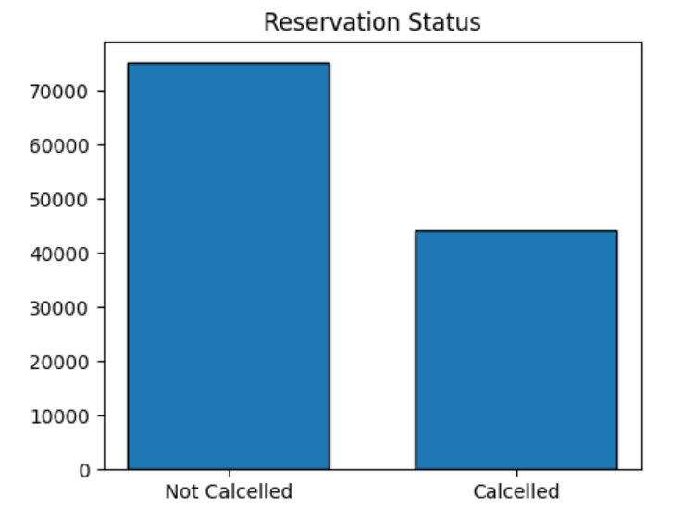

This bar graph shows the % of reservation that are cancelled and those which are not. There are 37% of clients who cancelled reservations which has significant impact on hotel’s earnings.

2.

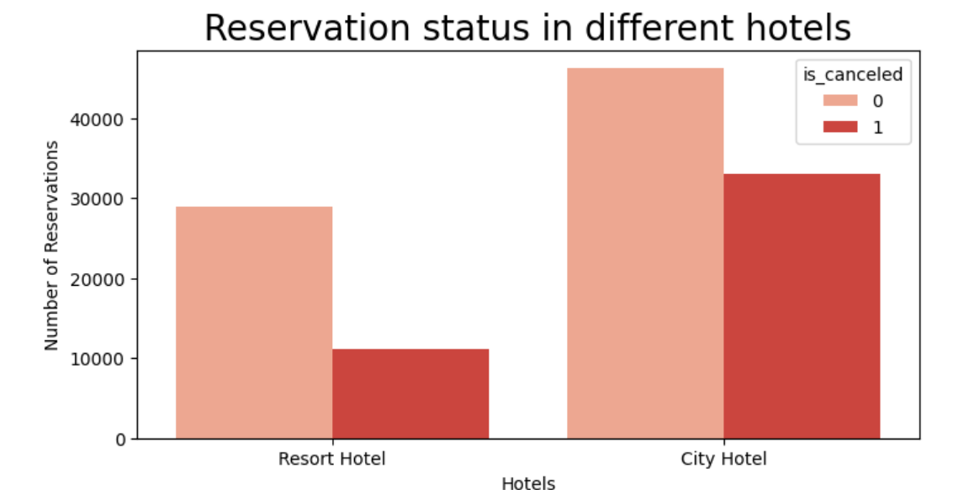

This countplot shows that in comparision to Resort Hotels, City Hotels have more bookings. It’s possible that Resort Hotels are more Expensive.

3.  
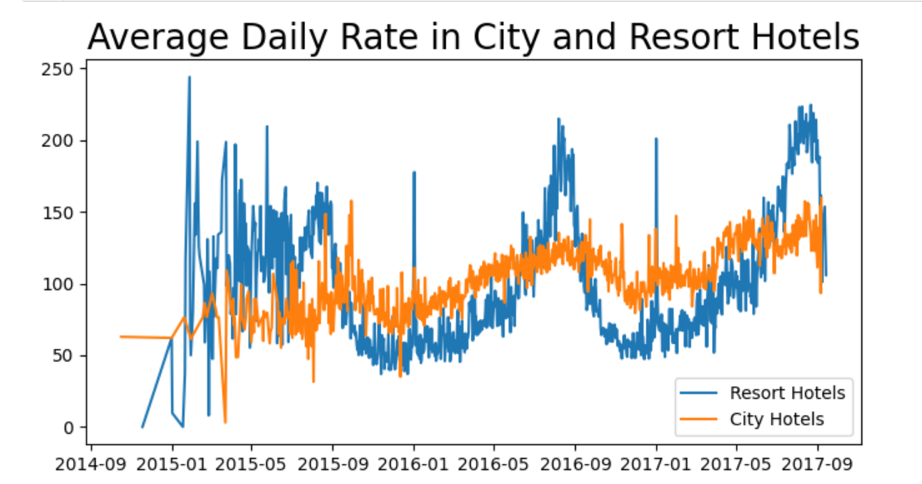

This line plot shows the price fluctuation in Resort Hotels and City Hotels over a course of 3 years (2014 - 2017). Resort Hotels are more expensive than City Hotels on an average.

4.  
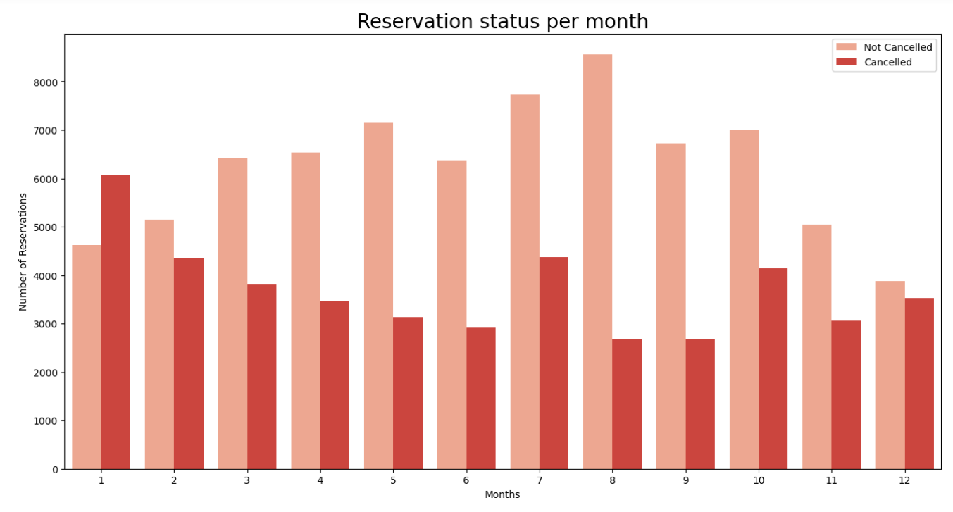

This grouped bar graph shows the months with the highest cancellations as well as the months with the lowest cancellations. As seen, January has most number of cancellations whereas August has most number of Non cancellations.

5.  
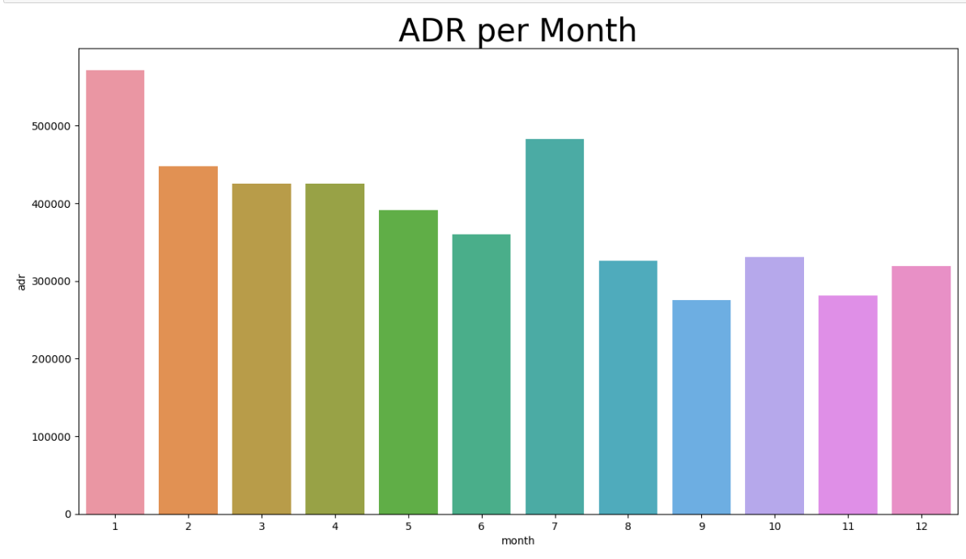

This plot demonstrates that the cancellations are most common when the prices are greatest and least common when they are lowest. Therefore the cost of accomodation is solely responsible for the cancellation.

6.  
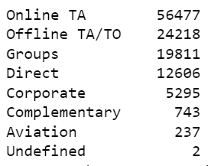

This shows how many bookings were done and through which mode. As seen, 56,000 bookings were done through Online Trave Agents which is nearly half of the overall bookings.

7.   
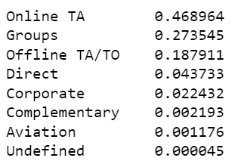

This shows how many cancellations were made and through which mode. As seen, more than 46% of all bookings were cancelled through onine agents.

8.   
 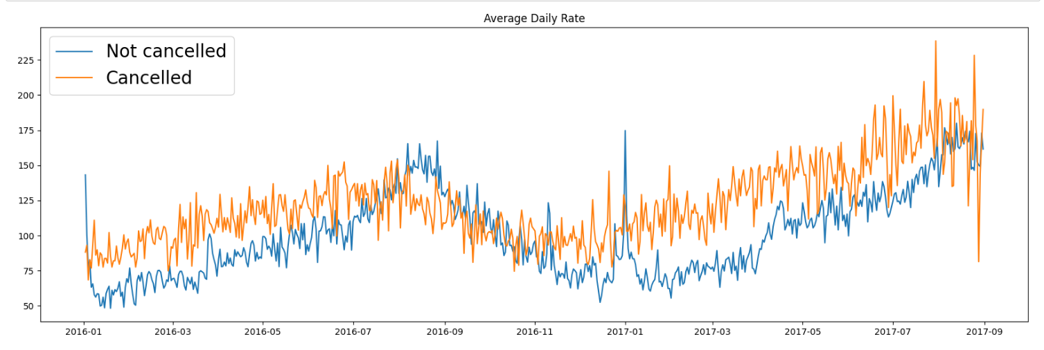

This shows that reservations are cancelled when the ADR( Average Daily Rate) is higher. It clearly proves all above analysis that higher price leads to higher cancellations.

Suggestions  
 1. Cancellation rates rise as the price does. In order to prevent cancellations, hotels could work on their pricing strategies based on specific locations where bookings may be more. They can also provide some discounts to their customers.  
 2. The company could provide reasonable discounts on weekends and on month-ends.  
 3. Company could work on their pricing mainly on the Resort Hotels as their cancellations are more.  
 4. In the month of January, cancellations are the highest. So the hotel could work on some marketing strategies on that soecific month to attraxt more customers and give them discounts.